User registration in the Repository

Creating an account in the Repository of the University of Life Sciences is not mandatory but allows users to take advantage of additional functions. The account is free of charge.

To create a User account:
1. Go to the Repository home page: https://repozytorium.up.lublin.pl/en
2. Click on the Log in button in the upper right corner.
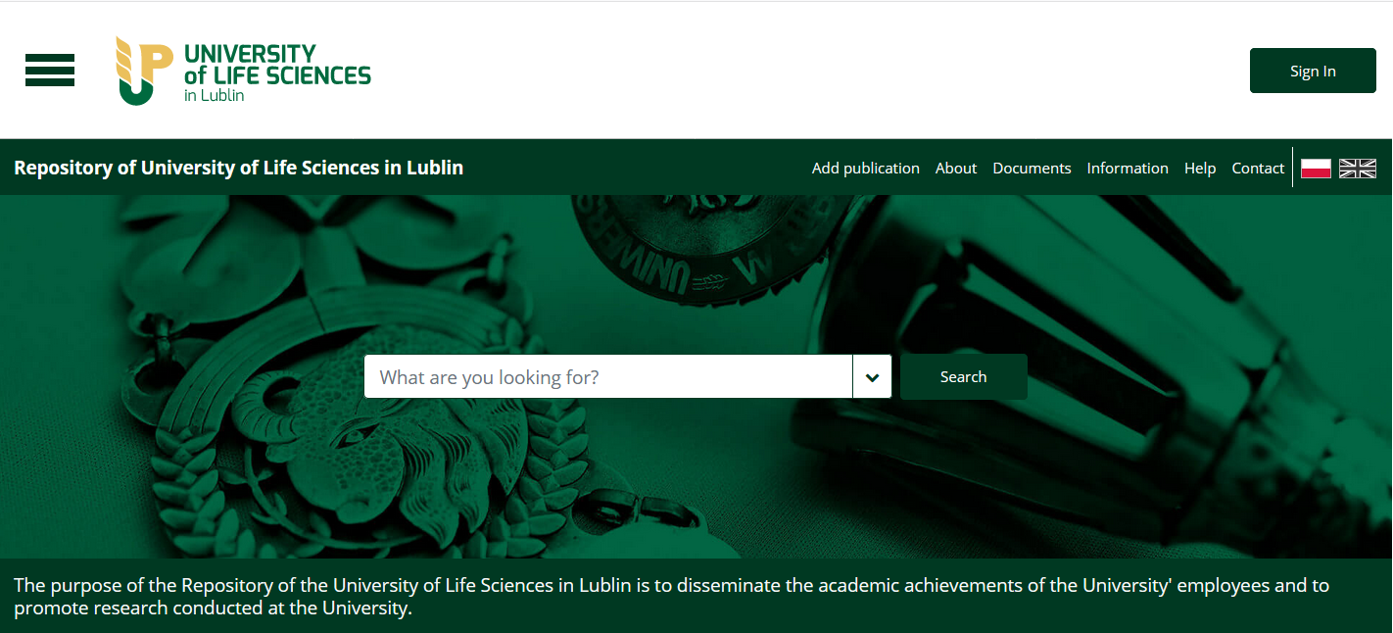
3. Click on the Register button, complete the form, and accept the required consents.

4. Confirm your account - click on the activation link sent to the e-mail address provided during the registration process.

LOGGING IN

- On the repository home page, select the Log in button in the upper right corner.

- Enter the information you have provided during registration and click on the Log in button.

USER PROFILE

Once logged in, click the drop-down menu in the upper left corner and select user profile.
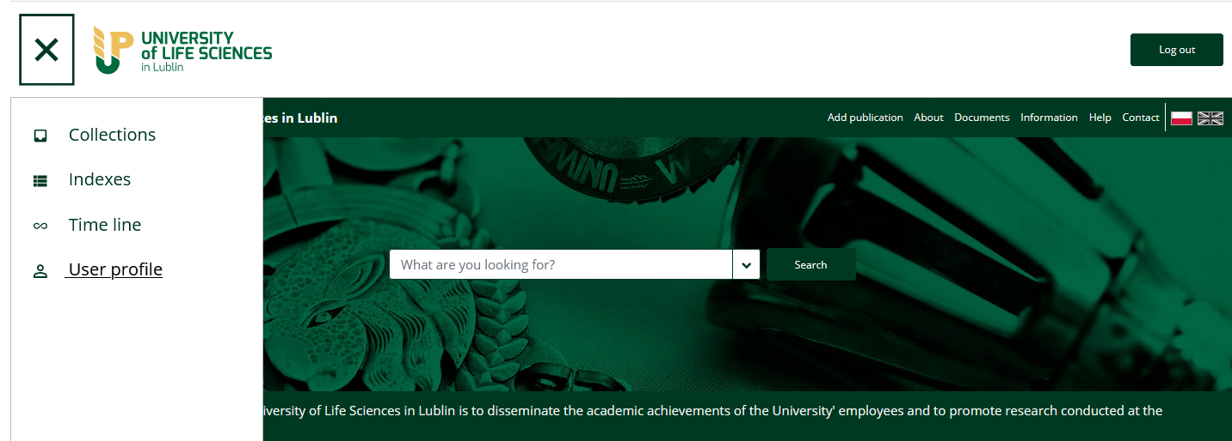

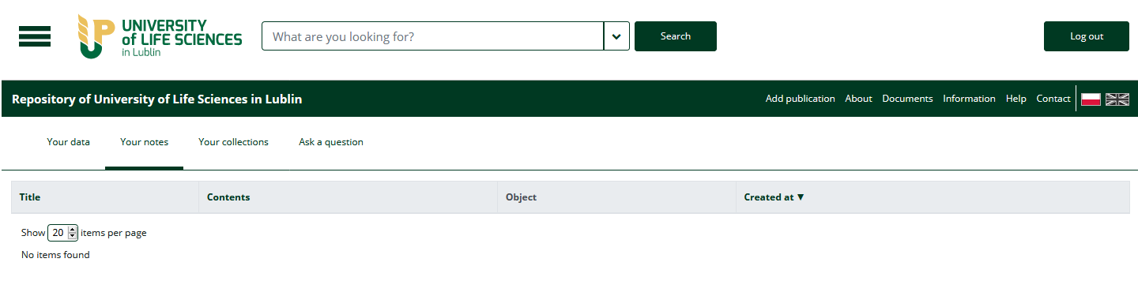

PASSWORD CHANGE

To change your password, log into your user account, select the Your data section and then Change password.
- Fill in the fields (enter your new password twice and your current password).
- Confirm the changes by clicking on the Update button.
